**HDR Image Processing Report**

### **Results**

The HDR image was processed using different combinations of HDR merging techniques and tone mapping methods. Each combination produces a unique output based on how the merging and tone mapping interact. The results include the **Dynamic Range** and **Contrast-to-Noise Ratio (CNR)**, which provide insight into the quality of the final HDR image.

#### **Dynamic Range**

The **Dynamic Range** is an essential metric for evaluating the effectiveness of the HDR processing. It measures the range of pixel intensity values in the final HDR image, reflecting the image’s ability to retain both bright and dark details. A higher dynamic range indicates that more detail has been preserved across the light and dark areas of the image.

For each combination of merging and tone mapping, the **maximum and minimum pixel values** are computed from the processed HDR image, and these values are displayed to provide insight into how well the HDR merging preserved the scene's dynamic range.

#### **Contrast-to-Noise Ratio (CNR)**

The **Contrast-to-Noise Ratio (CNR)** is calculated between two selected regions of interest (ROIs)—one in a bright region and one in a dark region. This metric is useful for evaluating how well the processed image maintains detail in the darker areas of the image, where noise is most likely to appear after tone mapping. A higher CNR value indicates better contrast and detail visibility in the darker regions.

For each combination of merging and tone mapping, the CNR value is computed and displayed.

#### **Sample Inputs**

By adjusting the **exposure values** based on the mobile settings you can use these three images.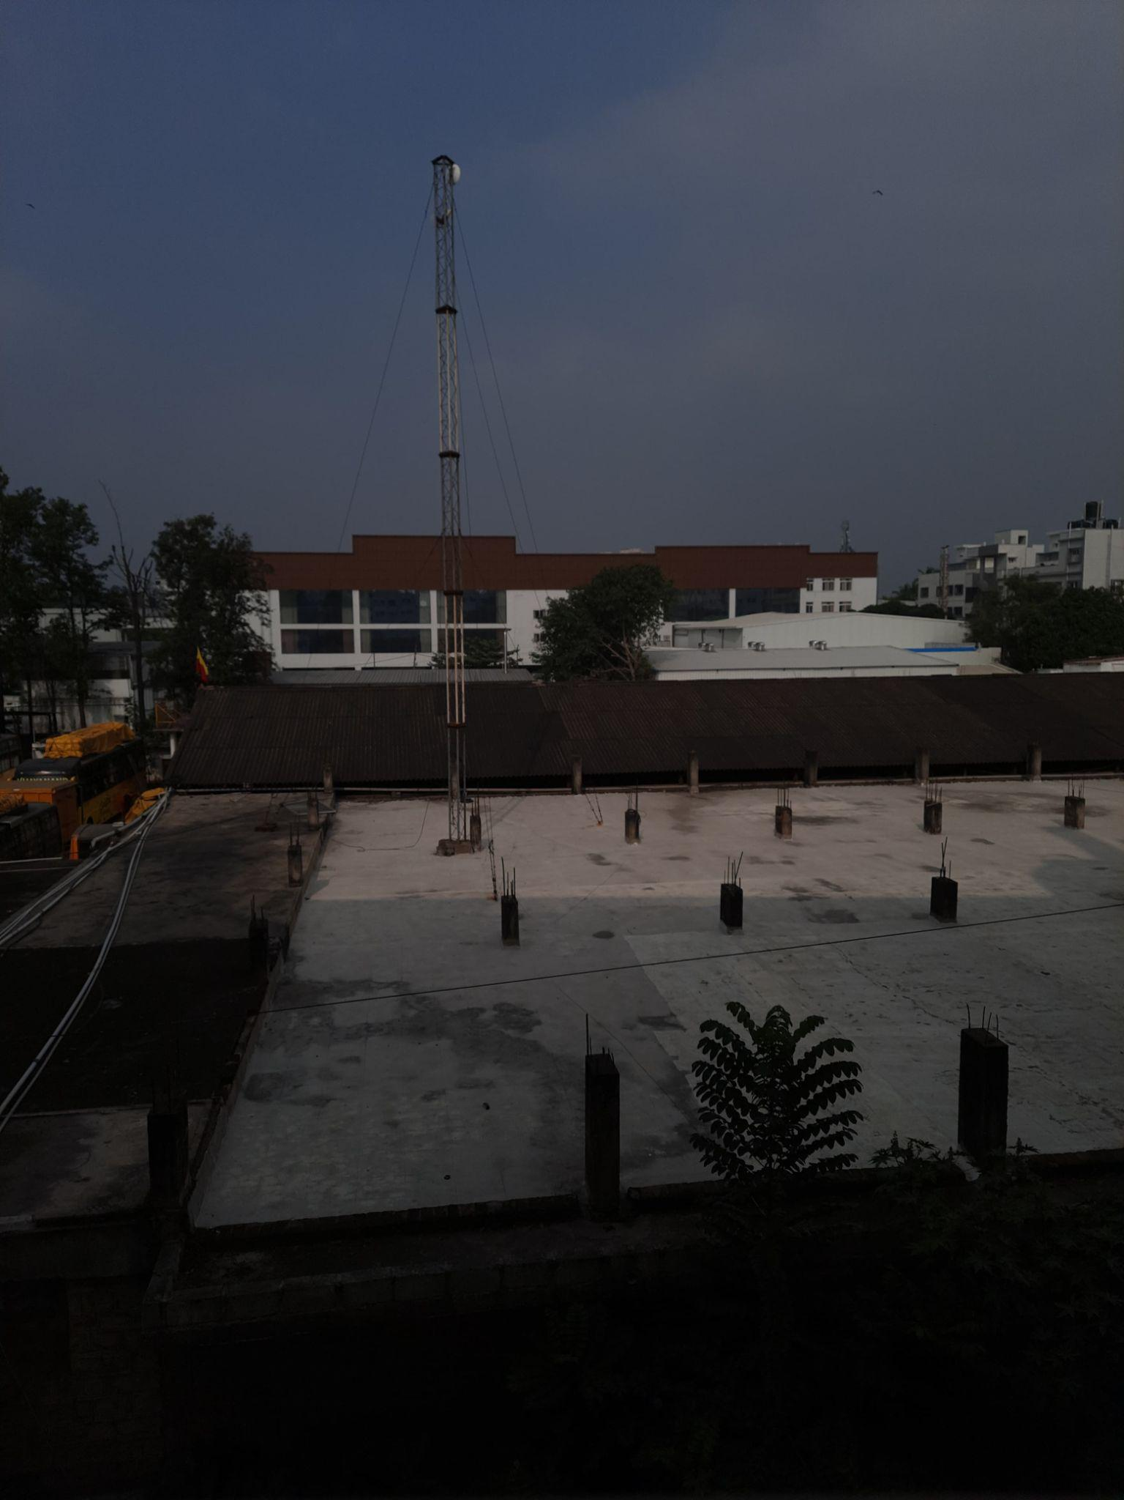

**Underexposed Image**: Use a **lower exposure value** (around **-2 to -3 EV**).

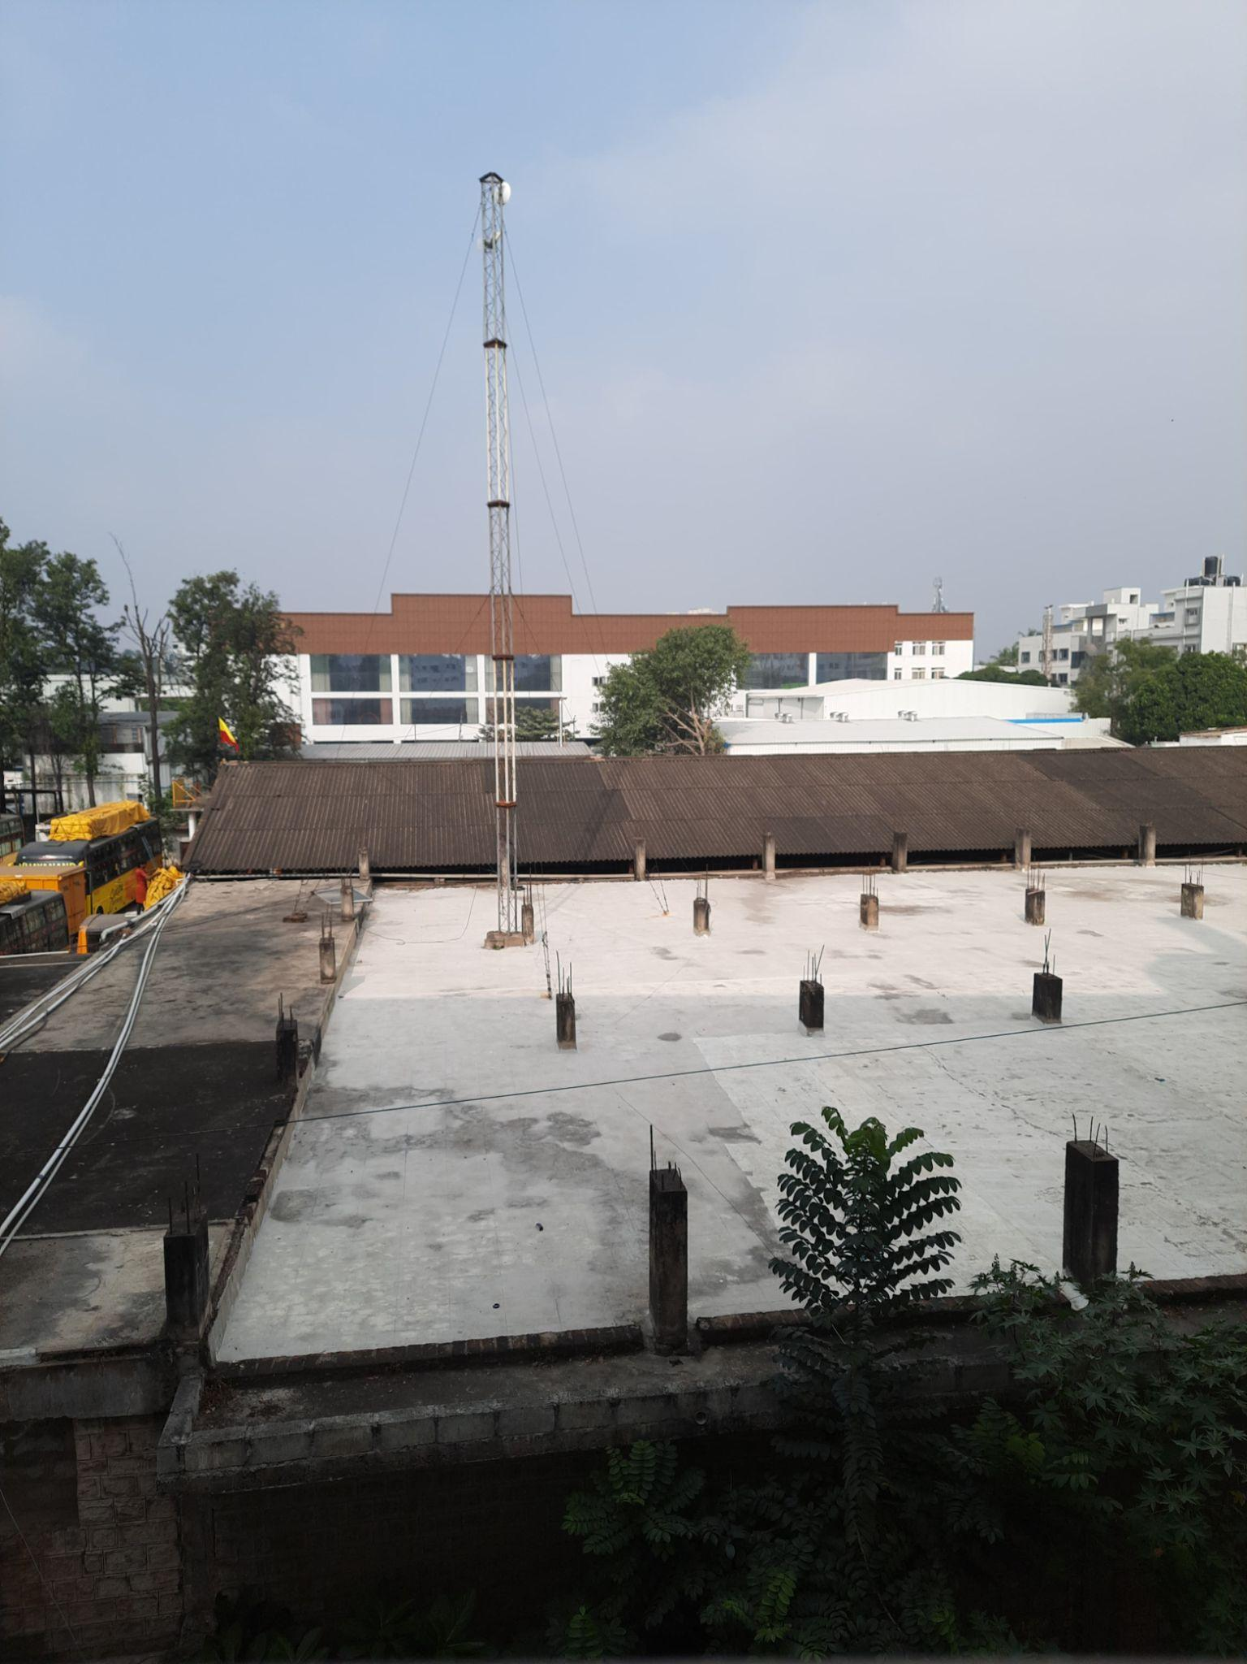

**Correctly Exposed Image**: Use an **exposure value of 0 EV**.

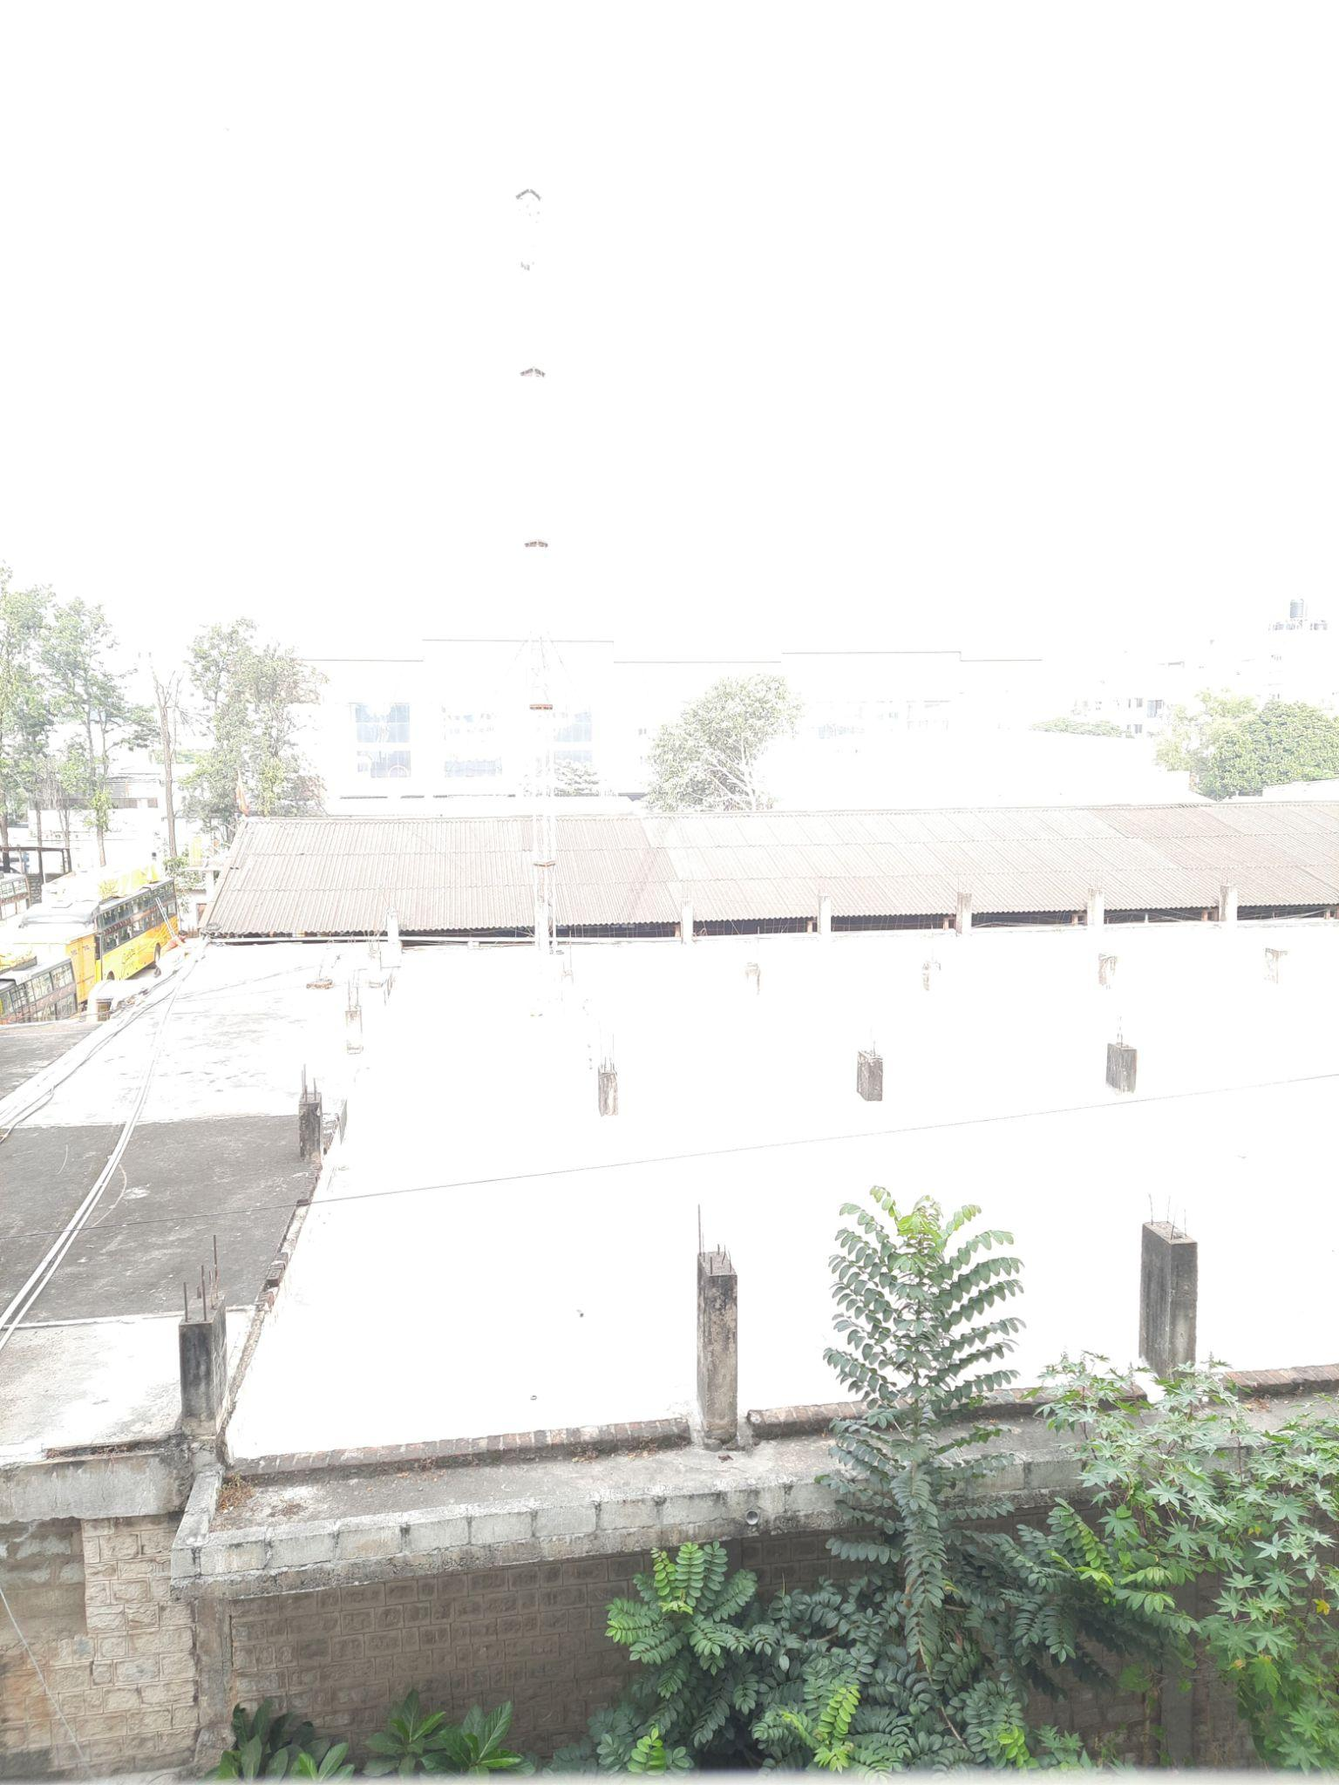

**Overexposed Image: Use a higher exposure value (around +2 to +3 EV).**

#### 

#### **Sample Output**

For each combination of **HDR Merging** and **Tone Mapping**, the following results are presented:

* **Processed HDR Image**: The final HDR image after merging and tone mapping.
* **Dynamic Range**: The maximum and minimum pixel values in the final HDR image, which reflect the preserved intensity range.
* **CNR**: The calculated contrast-to-noise ratio between the bright and dark regions of the final image.

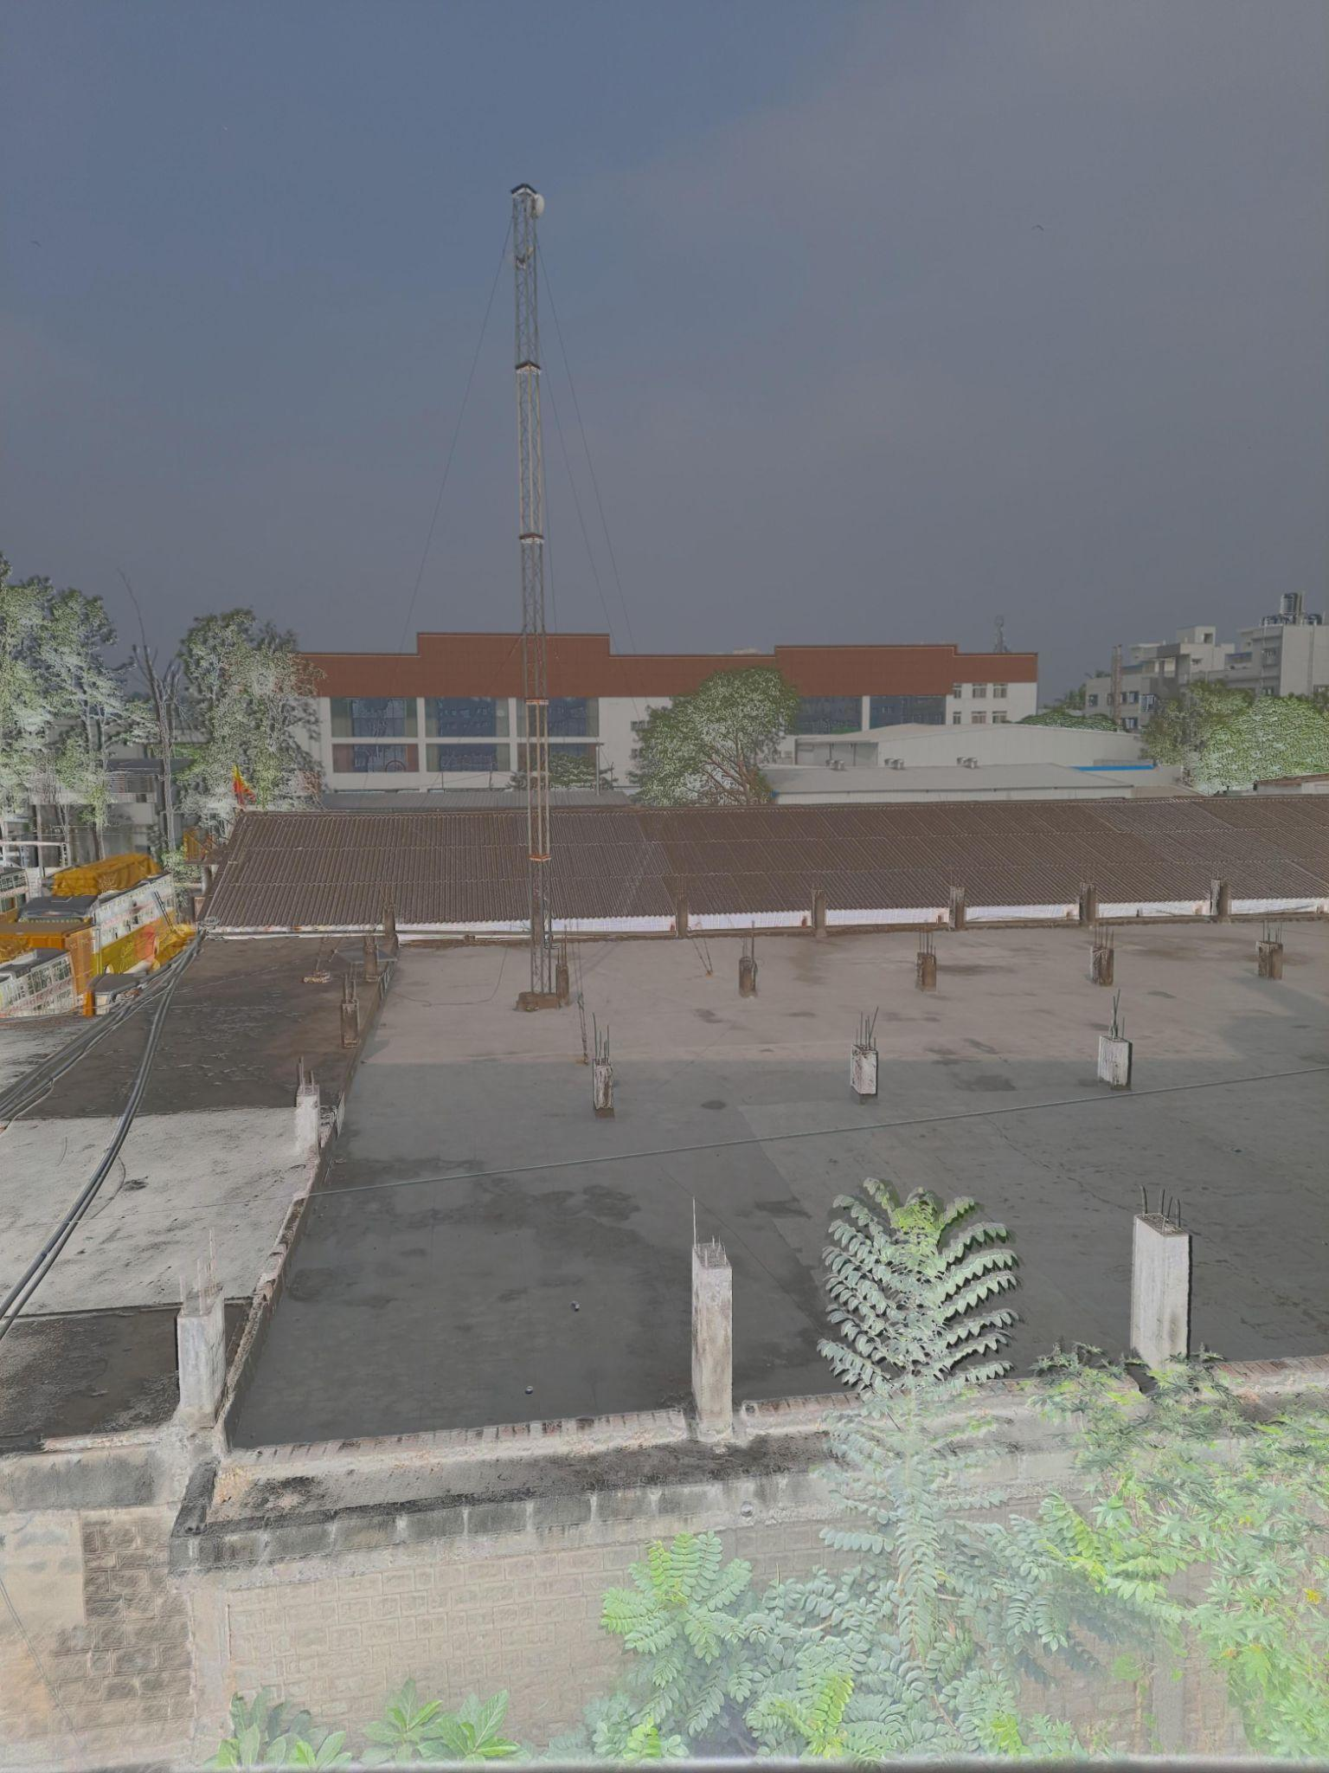

**Debevec with Reinhard**

Dynamic Range of HDR Image:

Max = 255.0,

Min = 0.0

Contrast-to-Noise Ratio (CNR) of HDR Image: 0.018594574321219293

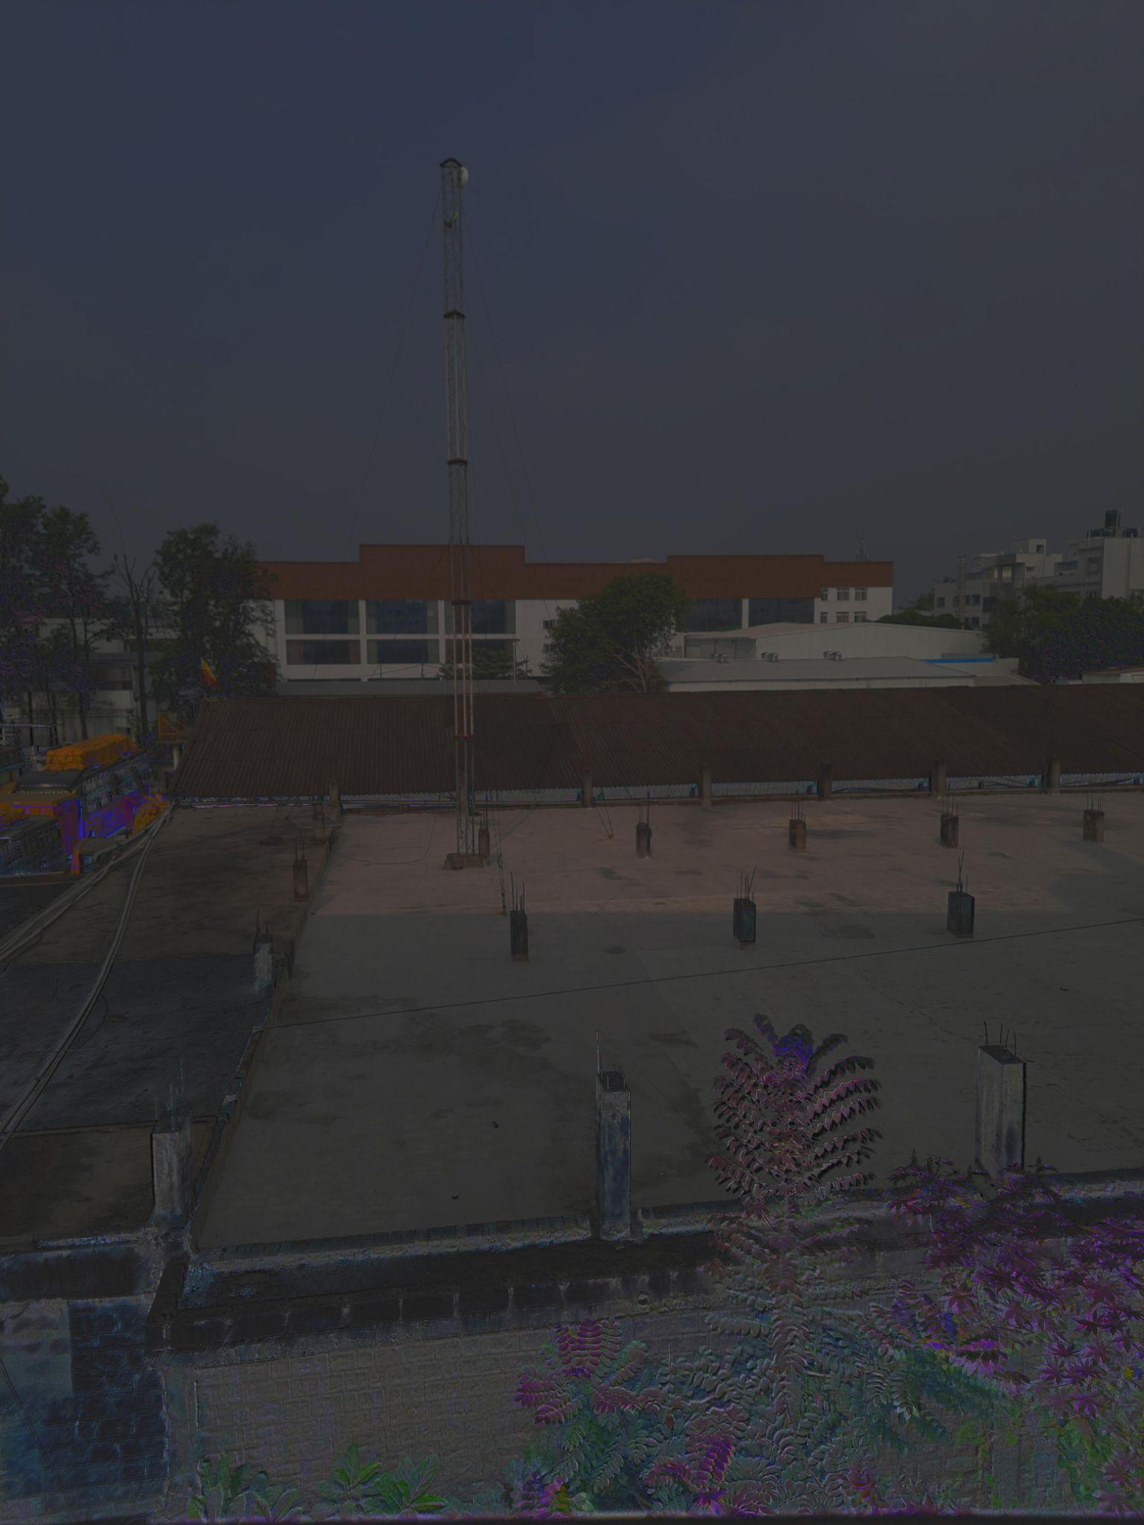

**Robertson with Reinhard**

Dynamic Range of HDR Image:

Max = 255.0, Min = 0.0 Contrast-to-Noise Ratio (CNR) of HDR Image: 0.0029108320916349795

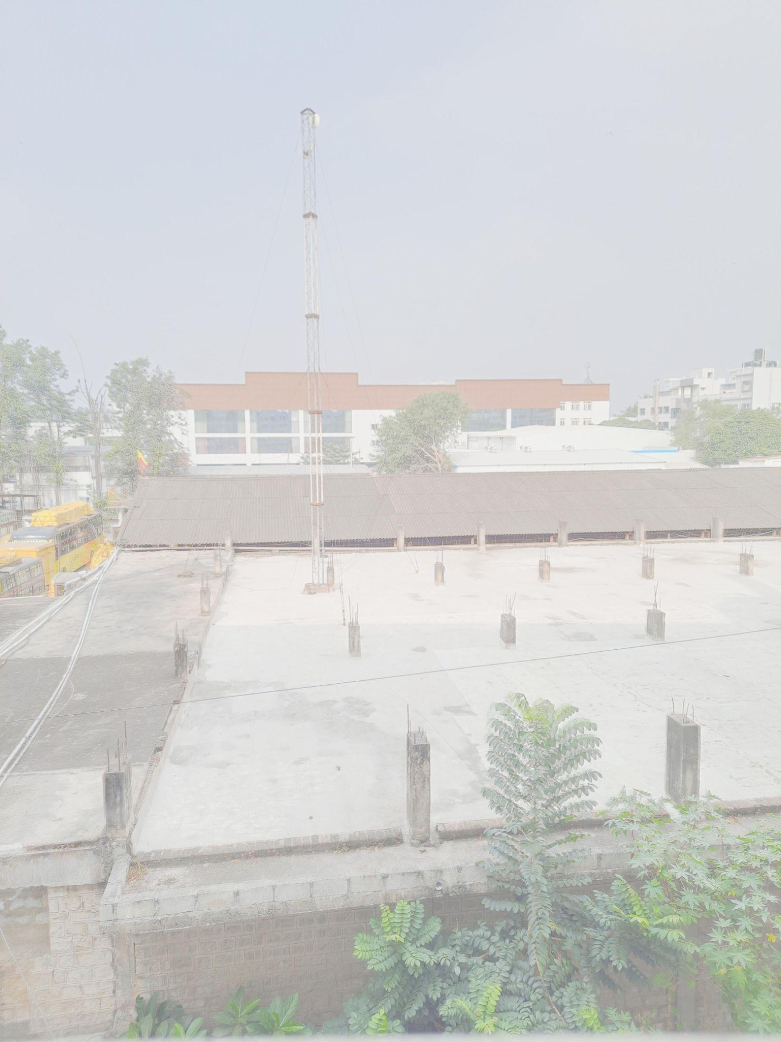

**Mertens Fusion (No HDR) with Reinhard**

Dynamic Range of HDR Image:

Max = 255.0, Min = 0.0

Contrast-to-Noise Ratio (CNR) of HDR Image: 0.0026798836425187505

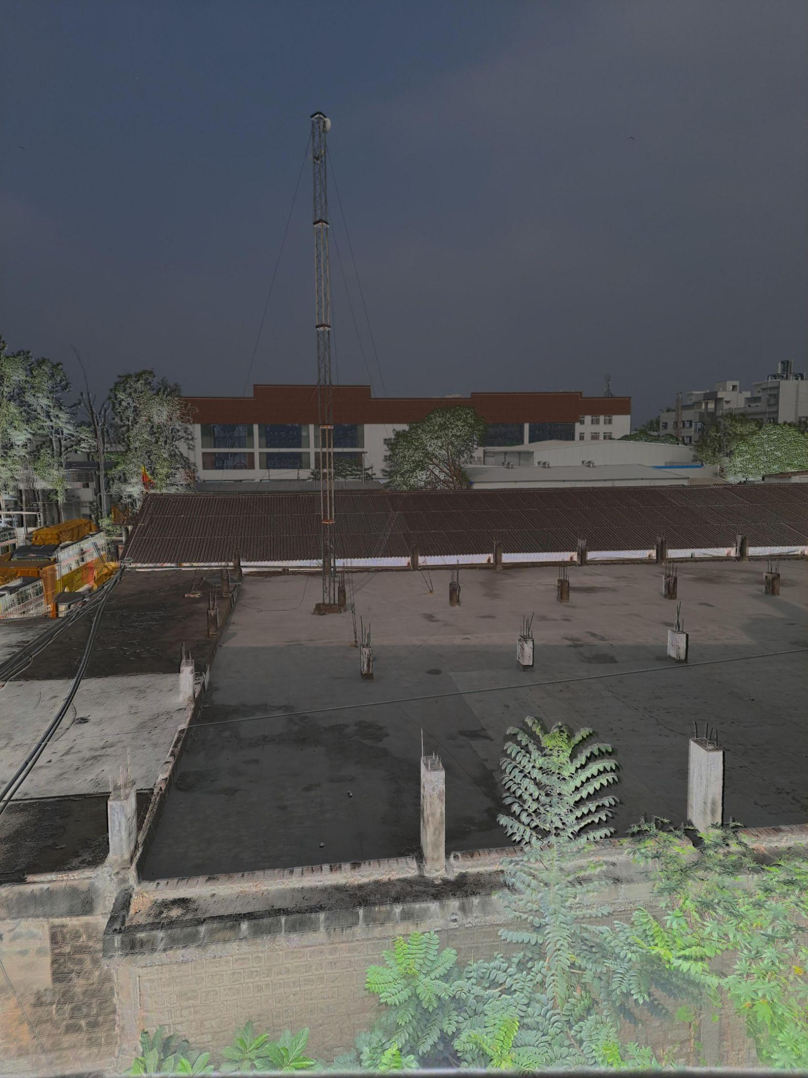

**Debevec with Drago**

Dynamic Range of HDR Image:

Max = 255.0, Min = 0.0

Contrast-to-Noise Ratio (CNR) of HDR Image: 0.01704467443865896

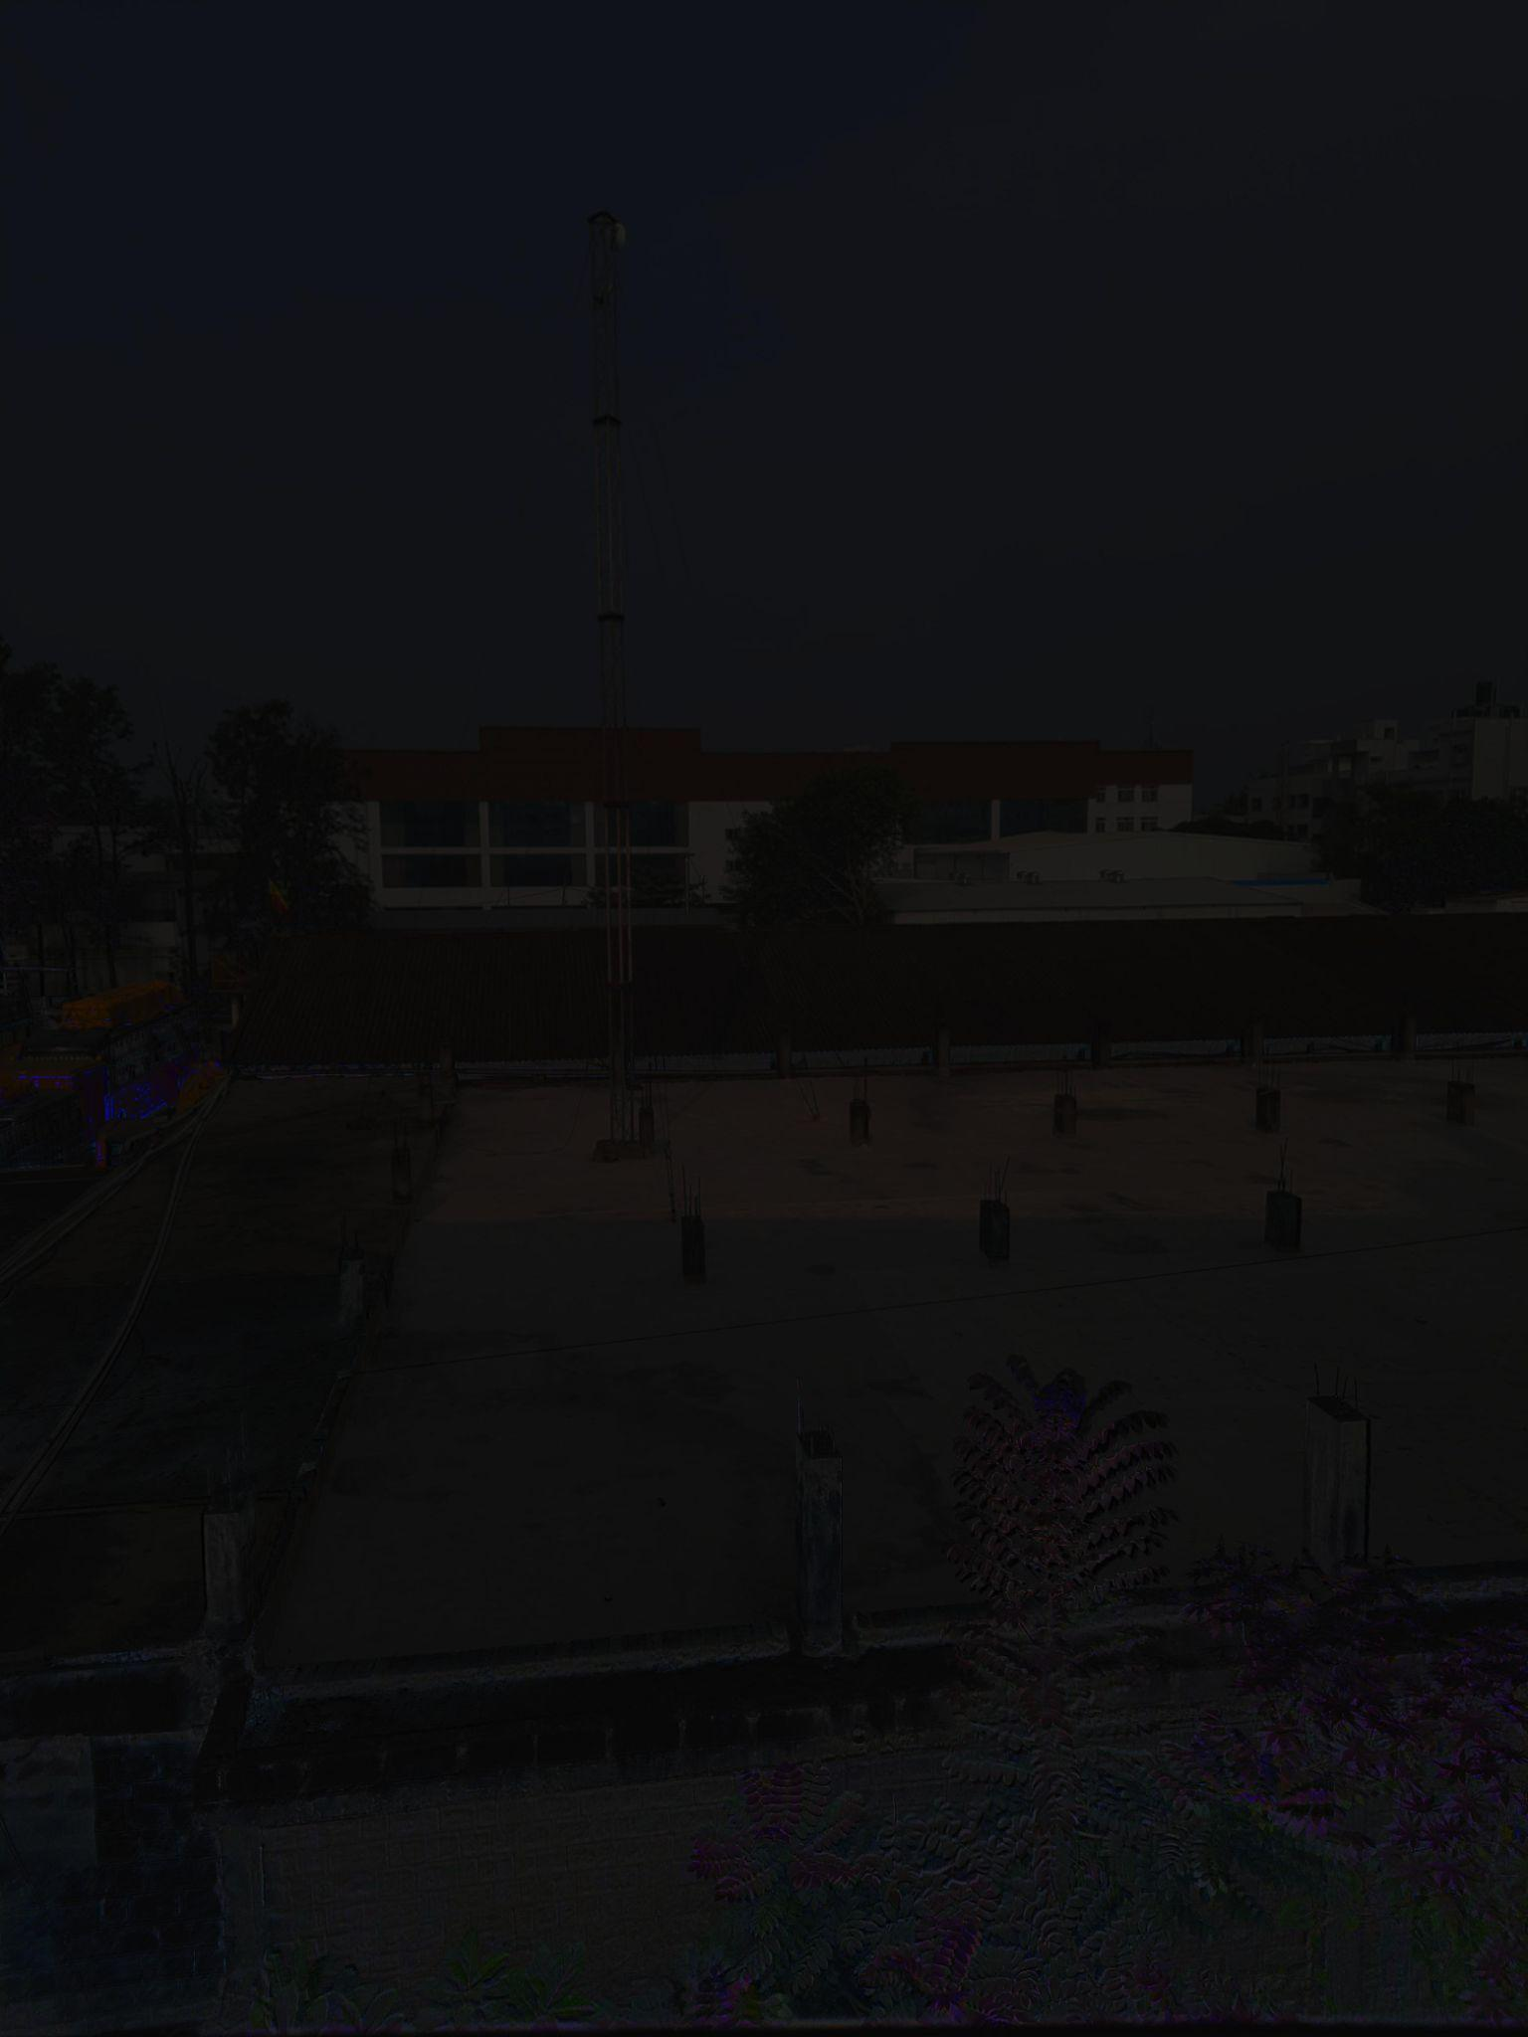

**Robertson with Drago**

Dynamic Range of HDR Image:

Max = 255.0, Min = 0.0

Contrast-to-Noise Ratio (CNR) of HDR Image: 0.008584312791493616

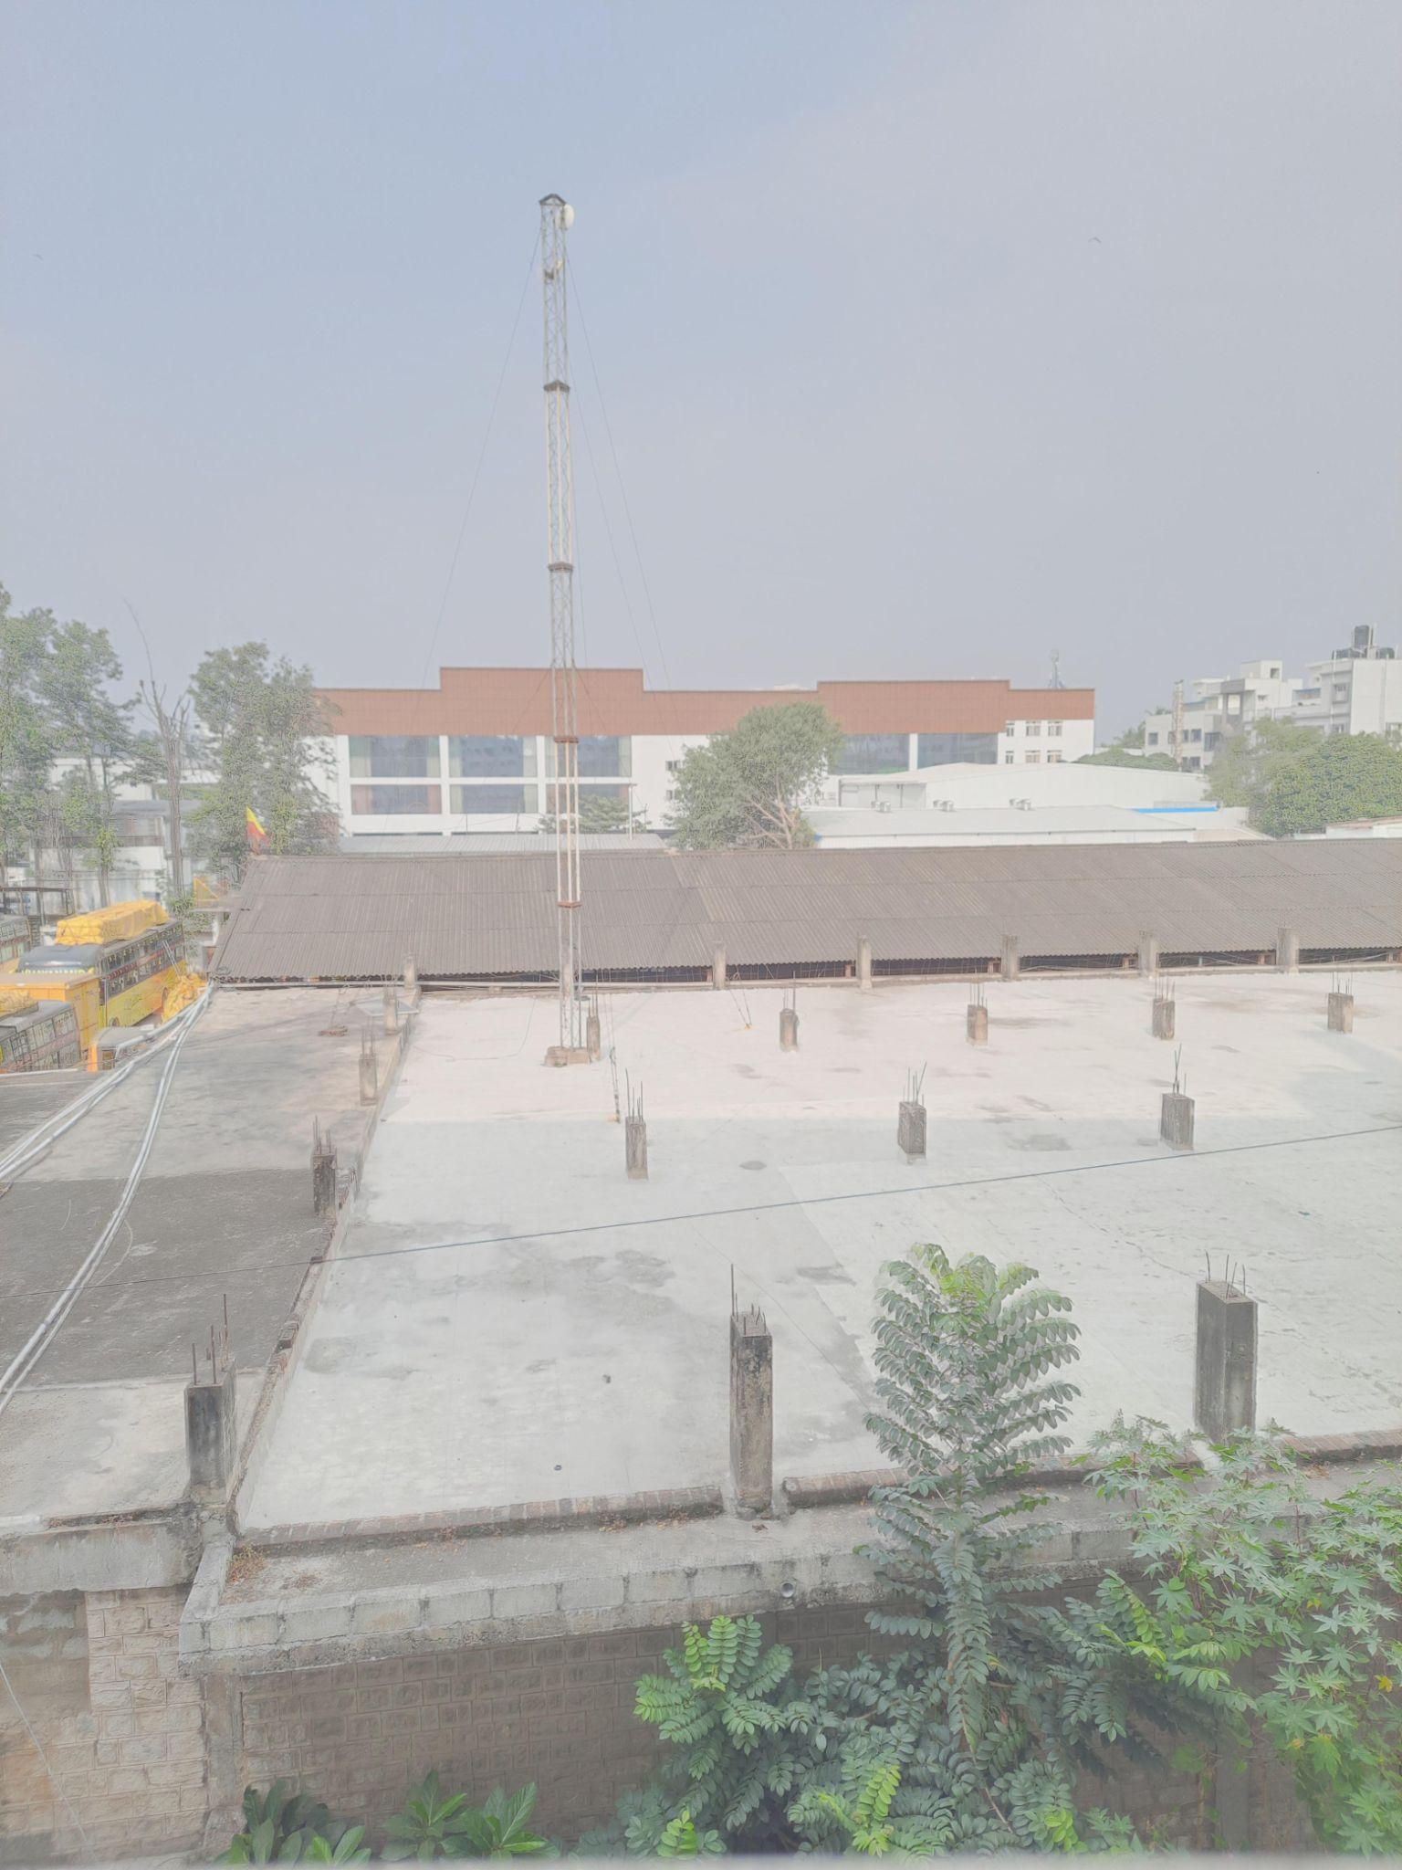

**Mertens Fusion (No HDR) with Drago**

Dynamic Range of HDR Image:

Max = 255.0, Min = 0.0

Contrast-to-Noise Ratio (CNR) of HDR Image: 0.005213102566997122

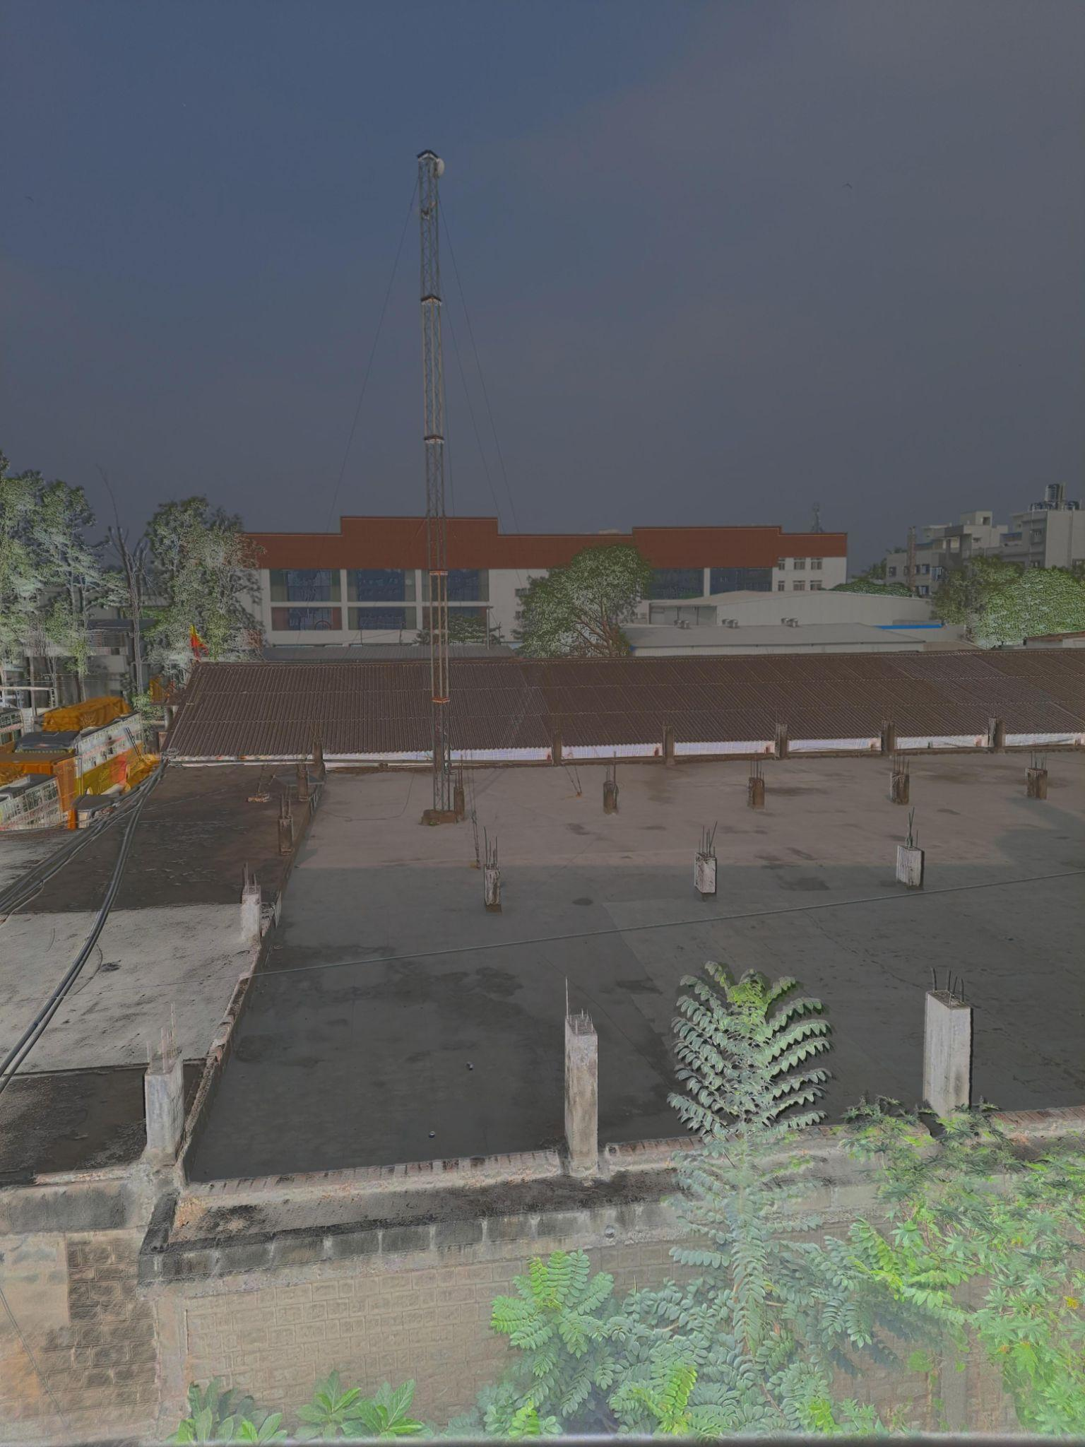

**Debevec with Mantiuk**

Dynamic Range of HDR Image:

Max = 255.0, Min = 0.0

Contrast-to-Noise Ratio (CNR) of HDR Image: 0.011478075498097824

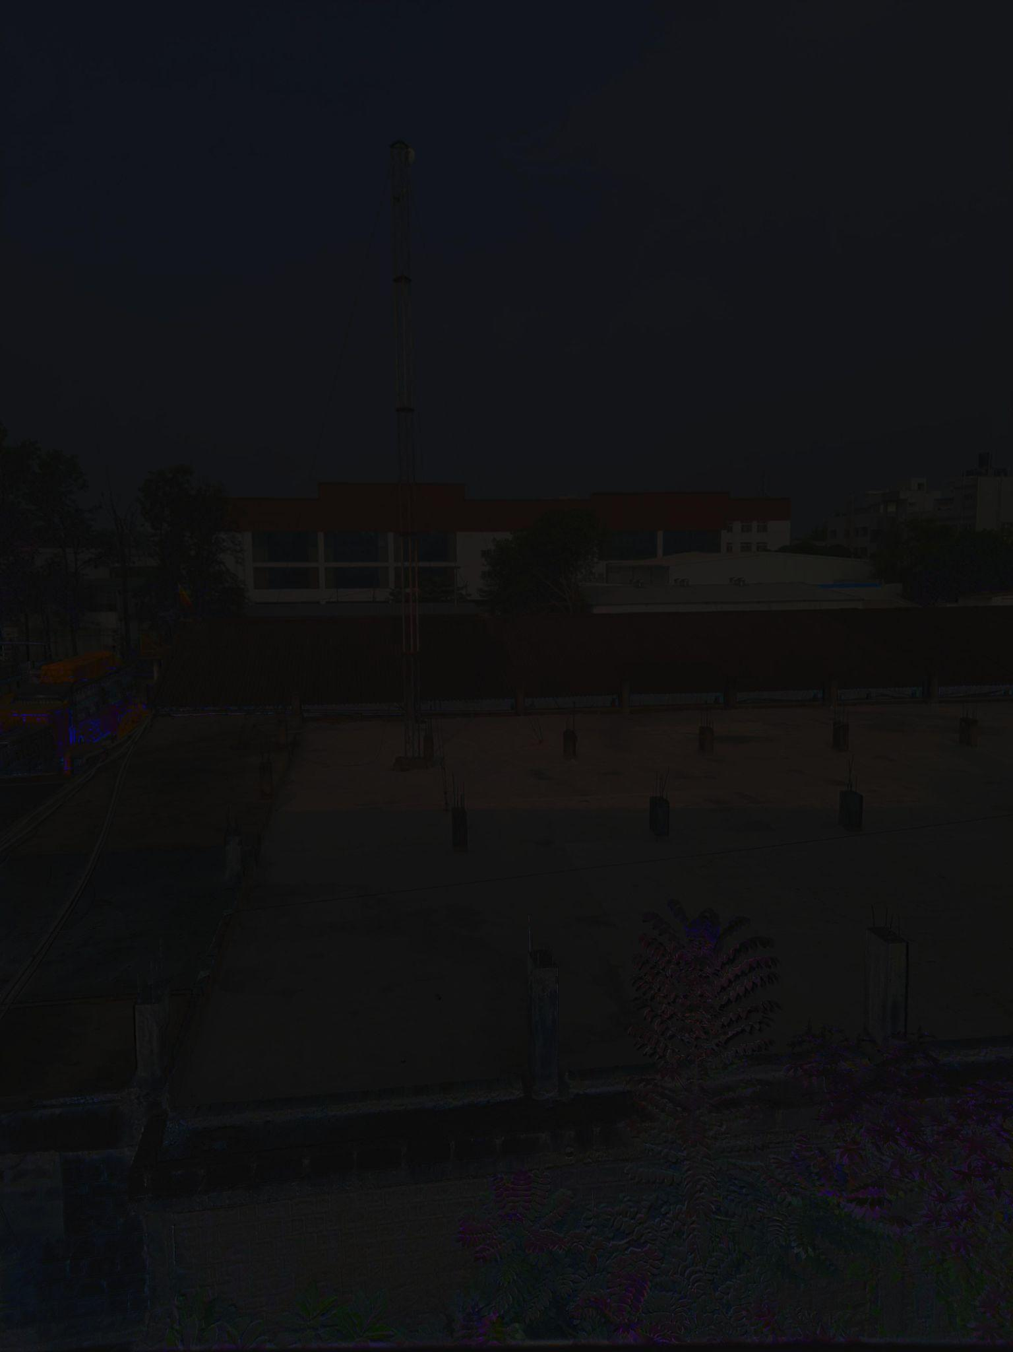

**Robertson with Mantiuk**

Dynamic Range of HDR Image:

Max = 255.0, Min = 0.0

Contrast-to-Noise Ratio (CNR) of HDR Image: 0.08324288482061404

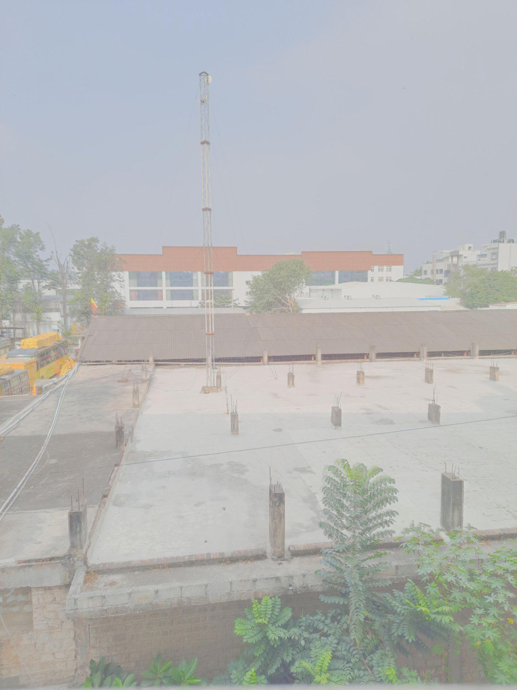

**Mertens Fusion (No HDR) with Mantiuk**

Dynamic Range of HDR Image:

Max = 255.0, Min = 0.0

Contrast-to-Noise Ratio (CNR) of HDR Image: 0.0005907443942340494

### **Summary:**

1. **Dynamic Range:** All combinations preserved the full dynamic range (0.0–255.0).
2. **Best Performer (Overall CNR):**
   * **Robertson with Mantiuk** had the highest CNR (0.08320.08320.0832), indicating excellent contrast preservation with minimal noise.
3. **Worst Performer:**
   * **Mertens Fusion (No HDR) with Mantiuk** had the lowest CNR (0.00060.00060.0006), highlighting high noise and poor contrast-to-noise balance.
4. **Tone Mapping Comparisons:**
   * **Mantiuk** generally outperformed Reinhard and Drago in terms of CNR.
   * **Reinhard** provided slightly better results compared to Drago for some combinations.
5. **HDR Merging Methods:**
   * **Debevec** and **Robertson** showed superior performance compared to **Mertens Fusion (No HDR)**, emphasizing the importance of HDR merging in achieving better results.

### **Recommendations:**

* Use **Robertson with Mantiuk** for applications requiring high contrast and low noise.
* Avoid **Mertens Fusion (No HDR)**, especially with Mantiuk, as it fails to achieve good CNR.
* Select tone mapping operators based on specific requirements (e.g., Mantiuk for contrast, Reinhard for balance).